**PaNOSC**

**Photon and Neutron Open Science Cloud**

**H2020-INFRAEOSC-04-2018**

**Grant Agreement Number: 823852**

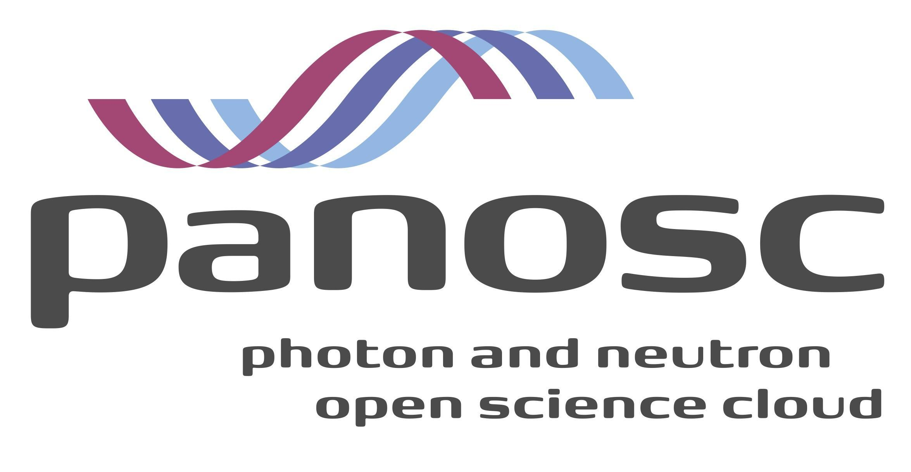

**Deliverable D8.3: Teaching materials for users of PaNOSC services, FAIR principles, and the PaNOSC facilities accessible in the e-learning platform at**[**pan-learning.org**](http://pan-learning.org)

# **Project Deliverable Information Sheet**

|  |  |
| --- | --- |
| Project Reference No. | 823852 |
| Project acronym: | PaNOSC |
| Project full name: | Photon and Neutron Open Science Cloud |
| H2020 Call: | INFRAEOSC-04-2018 |
| Project Coordinator | Andy Götz (andy.gotz@esrf.fr) |
| Coordinating Organization: | ESRF |
| Project Website: | www.panosc.eu |
| Deliverable No: | D8.3 |
| Deliverable Type: | DEC |
| Dissemination Level | Public |
| Contractual Delivery Date: | 31/05/2022 |
| Actual Delivery Date: | 08/11/2022 |
| EC project Officer: | Flavius Alexandru Pana |

## **Document Control Sheet**

|  |  |
| --- | --- |
| **Document** | Title: Teaching materials for users of PaNOSC services, FAIR principles, and the PaNOSC facilities accessible in the e-learning platform at [pan-learning.org](http://pan-learning.org) |
| Version: 1 |
| Available at: https://github.com/panosc-eu/panosc |
| Files: 1 |
| **Authorship** | Written by: Thomas Holm Rod & Andrew McCluskey |
| Contributors: Teodor Ivănoaica |
| Reviewed by: Mads Bertelsen, Aljosa Hafner, Mousumi Upadhyay Kahaly & Marius Retegan |
| Approved: Andy Götz |

## **List of participants**

|  |  |  |
| --- | --- | --- |
| **Participant No.** | **Participant organisation name** | **Country** |
| 1 | European Synchrotron Radiation Facility (ESRF) | France |
| 2 | Institut Laue-Langevin (ILL) | France |
| 3 | European XFEL (XFEL.EU) | Germany |
| 4 | The European Spallation Source (ESS) | Sweden |
| 5 | ELI European Research Infrastructure Consortium (ELI-ERIC) | Belgium |
| 6 | Central European Research Infrastructure Consortium (CERIC-ERIC) | Italy |
| 7 | EGI Foundation (EGI.eu) | The Netherlands |

## 

# **Introduction**

The e-learning platform contains a wide range of material, ranging from that supplement lectures in neutron scattering at Copenhagen University, to workshops used in teaching at the ISIS Neutron and Muon Facility. This report will focus on the material that was prepared as part of the PaNOSC summer school. This summer school focused on introducing PaNOSC services, FAIR principles and the PaNOSC facilities, in application to materials science topics.

# **Summary of prepared training content**

E-learning material was developed for the PaNOSC summer school **Material Science at European Large-Scale Infrastructures using Open and FAIR Data** held September 12-16 in Szeged, Hungary. The material is accessible in the e-learning platform: <https://e-learning.pan-training.eu> under the heading:

*PaNOSC Summer School 2022* at <https://e-learning.pan-training.eu/moodle/course/view.php?id=108>

The material covers FAIR data at the types of research infrastructures in PaNOSC, i.e. laser facilities, synchrotron (x-ray) facilities, and neutron sources. The various material is listed in the table below and together encompasses Deliverable D8.3.

|  |  |  |  |  |
| --- | --- | --- | --- | --- |
| Title | Topic |  | Functionality used in e-learning platform | Link |
| FAIR session | FAIR data, open science, EOSC |  | Moodle | <https://e-learning.pan-training.eu/moodle/course/view.php?id=114> |
| Laser focus day | FAIR laser science |  | Moodle & Jupyter | <https://e-learning.pan-training.eu/moodle/course/view.php?id=111> |
| Neutron focus day | FAIR neutron science |  | Moodle & Jupyter | <https://e-learning.pan-training.eu/moodle/course/view.php?id=109> |
| x-ray focus day | FAIR x-ray science |  | Moodle & Jupyter | <https://e-learning.pan-training.eu/moodle/course/view.php?id=110> |

1. Note that user registration is required to access the training content.

The FAIR data introduction was delivered by Dr Andy Götz (ESRF) representing the PaNOSC project at large and the concepts of FAIR. A screenshot from this material is shown below. This material is student-led including online quizzes, enabling active learning to improve student engagement. The laser focus day was prepared by Dr Mousumi Upadhyay Kahaly (ELI-ALPS) and investigates the analysis and interpretation of simulation methods complementary to ultrafast laser science. The neutron-focus day introduces quasi-elastic neutron scattering and modelling approaches that can be used to analyse these datasets (taking advantage of the hdf5viewer developed in WP4), this was prepared by Dr Andrew McCluskey (ESS). The x-ray focus day material, prepared by Dr Marius Retegan (ESRF), covering x-ray spectroscopy data reduction and analysis (leveraging FAIR data available through the ESRF open data portal) . All three focus days take advantage of the ability to include interactive Jupyter Notebooks to improve student engagement and promote and active relationship with the subject of study. Throughout the focus day materials, a particular focus is given to the role of data in the measurements that can be made at the PaNOSC facilities and the PaNOSC services that may be utilised.

